ECS-COPILOT

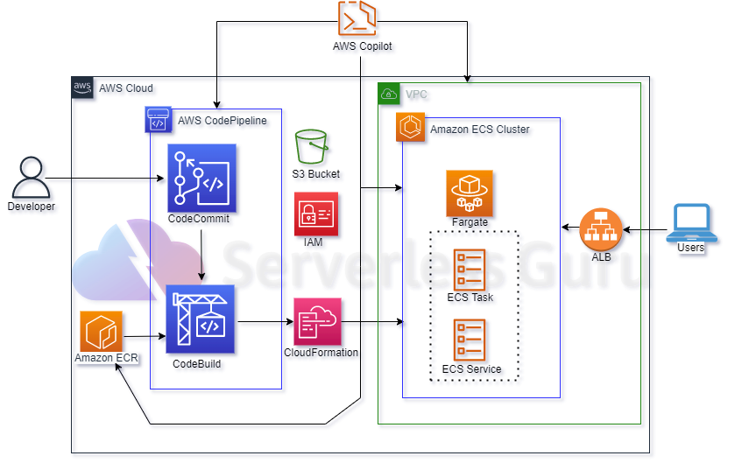

**Using Copilot**

AWS Copilot is a command line interface (CLI) that you can use to quickly launch and manage containerized applications on AWS. It simplifies running applications on Amazon Elastic Container Service (ECS), AWS Fargate, and AWS App Runner.

So we have to use AWS Copilot CLI to create Infra on AWS and also create a CI/CD pipeline. On AWS using AWS Copilot

We need a containerized applications to be deploy on ECS Cluster (Fargate). With its dockerfile.

While using AWS Copilot it makes all the infra related to it by itself (ECR repo, ECS task, Loadbalancer etc.). It first creates CloudFormations stack’s then it deploys those stacks.

While creating a CI/CD pipeline it creates it’s own buildspec.yml that is use to be work creating a pipeline.